**LIT TRAINING**

**Batch Name : SAP ABAP -25                                                            DAY 4 ASSIGNMENT**

**EMPLOYEE ID – 46247689**

**Exercise – Create a Module pool program to display Employee details.**

**Creating the Module Pool Program**

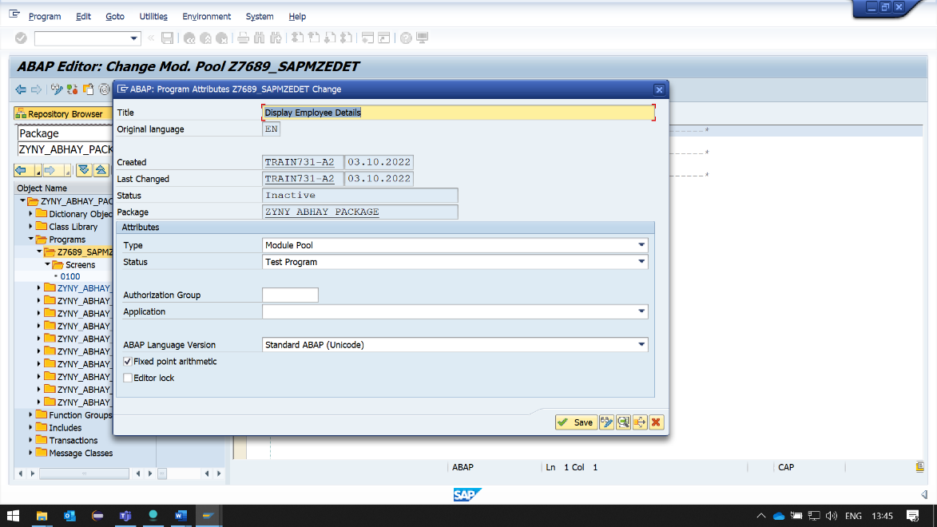

**Generate Screens using Screen Painter (Screen 0100)**

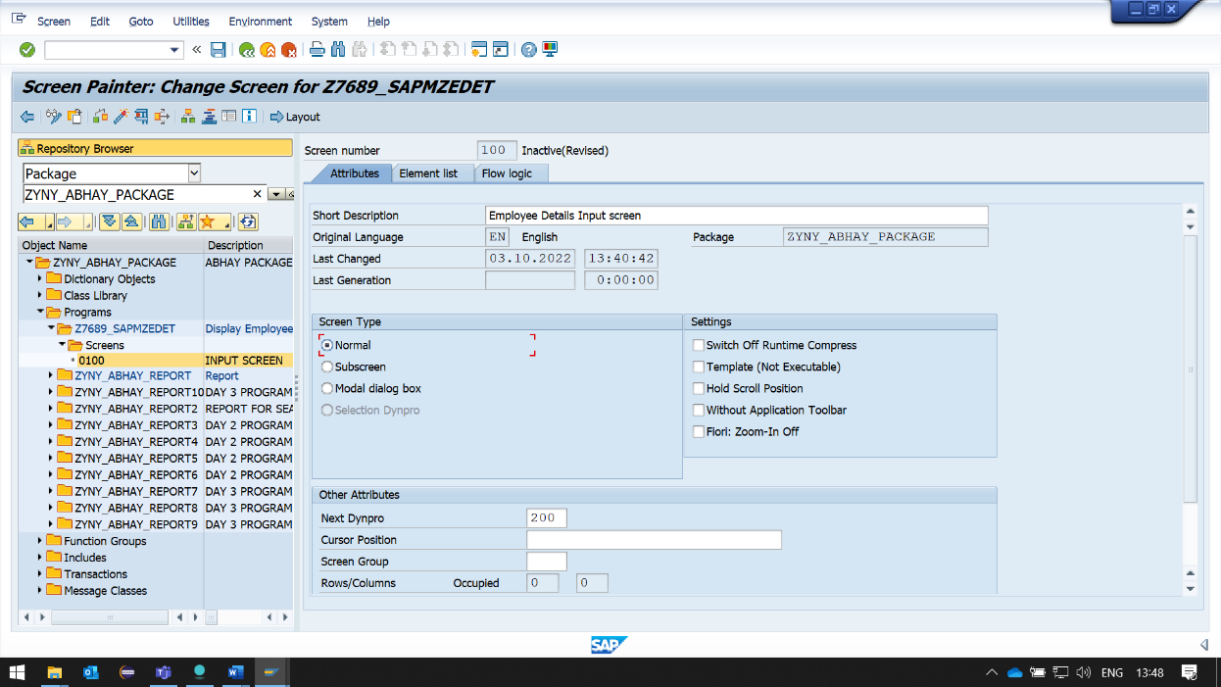

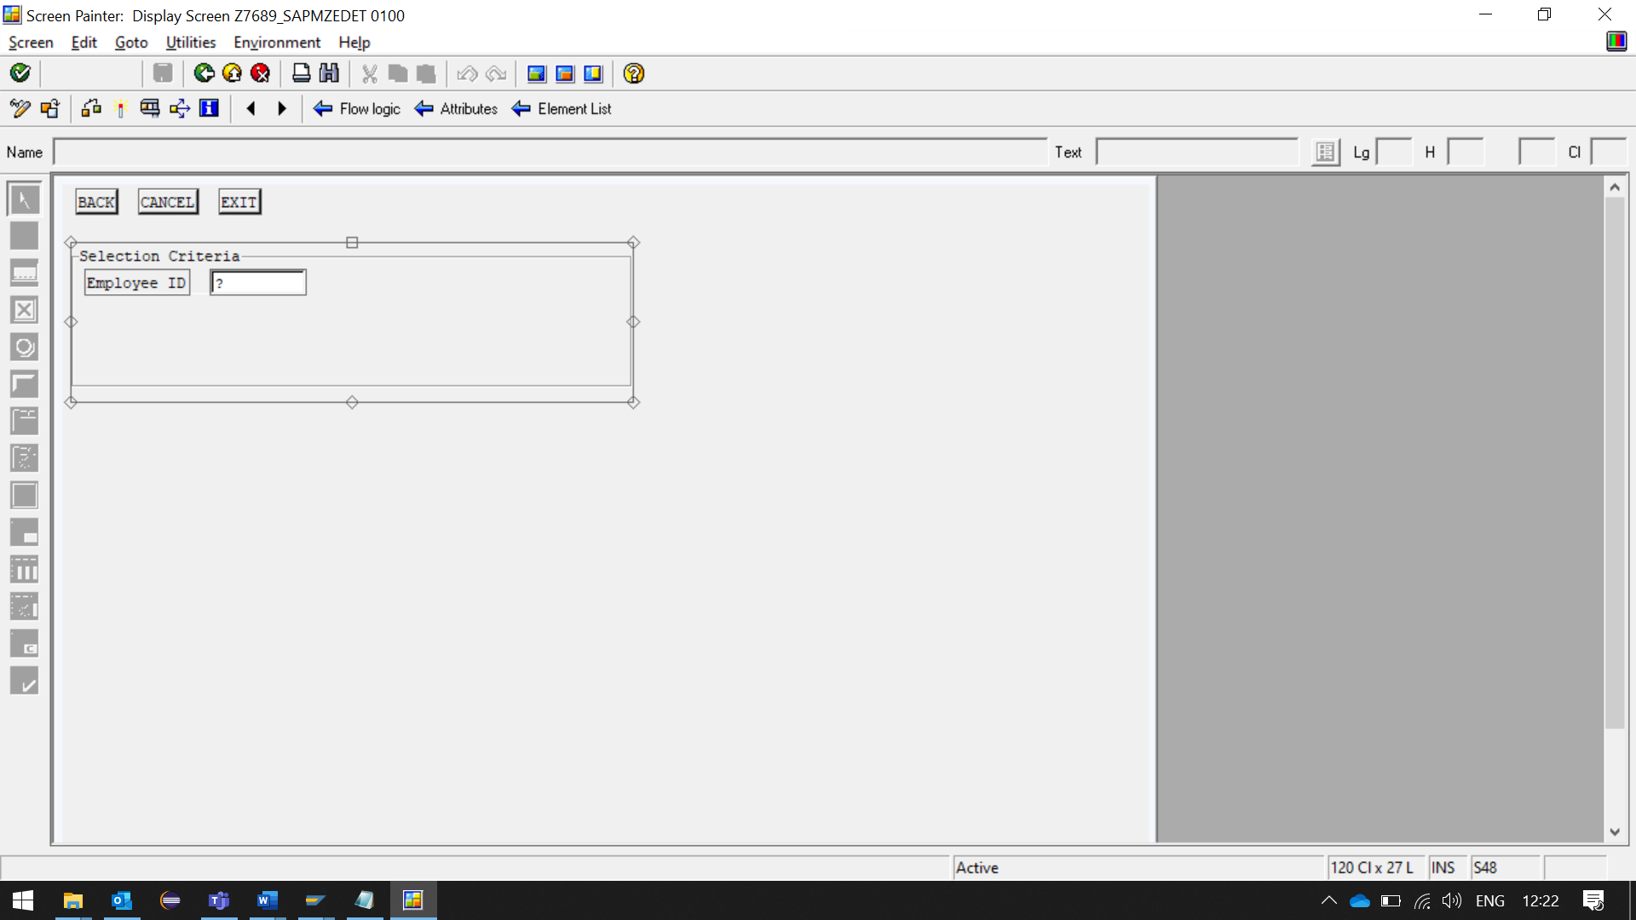

**Building the Flow Logic (Screen 0100)**

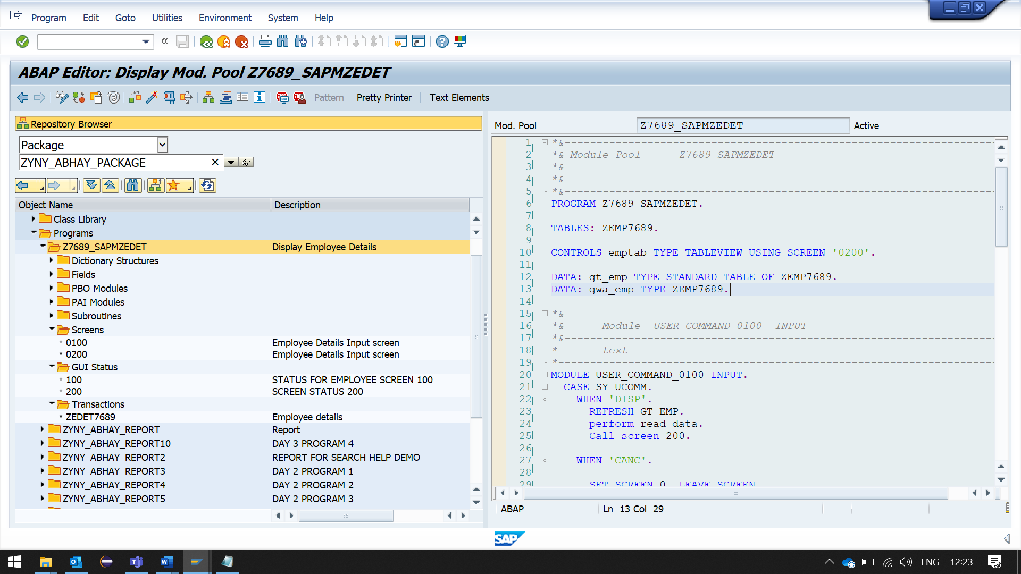

**Process After Input (PAI) module (Screen 0100)-**

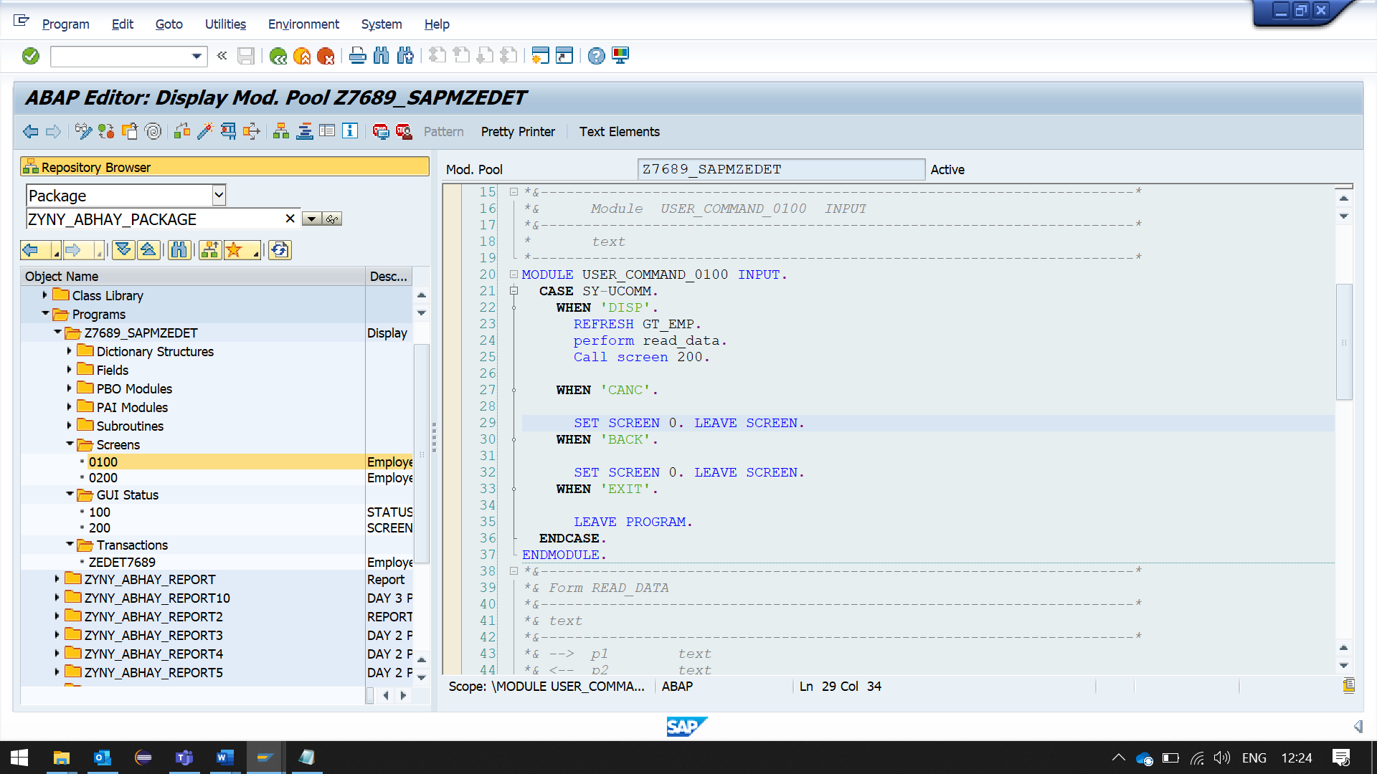

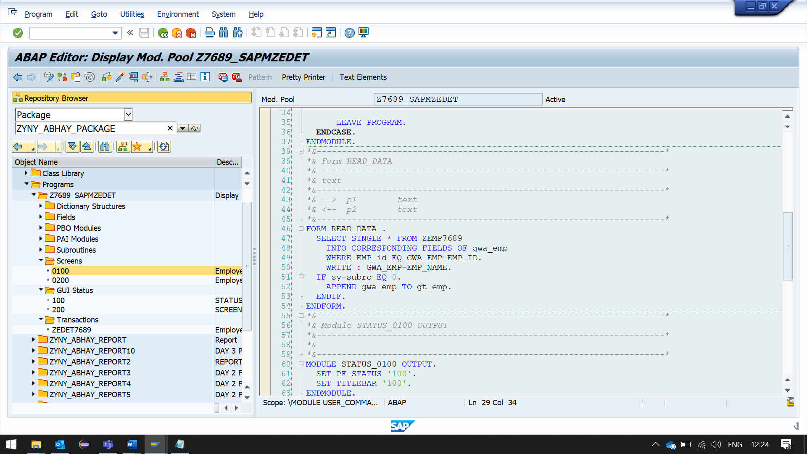

**Process Before Output (PBO) module (Screen 0100)-**

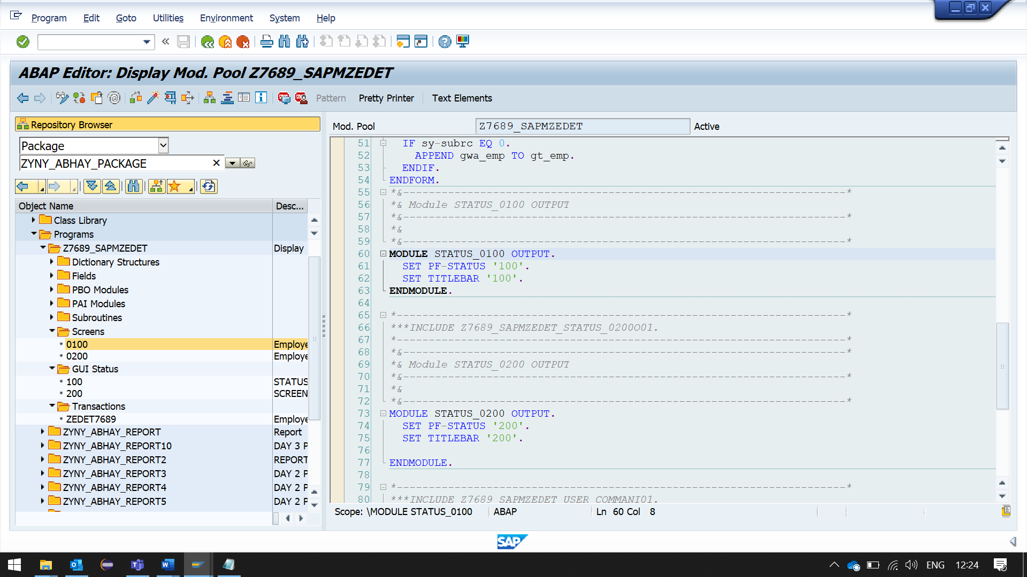

**Creating a GUI Status for the screen 100**

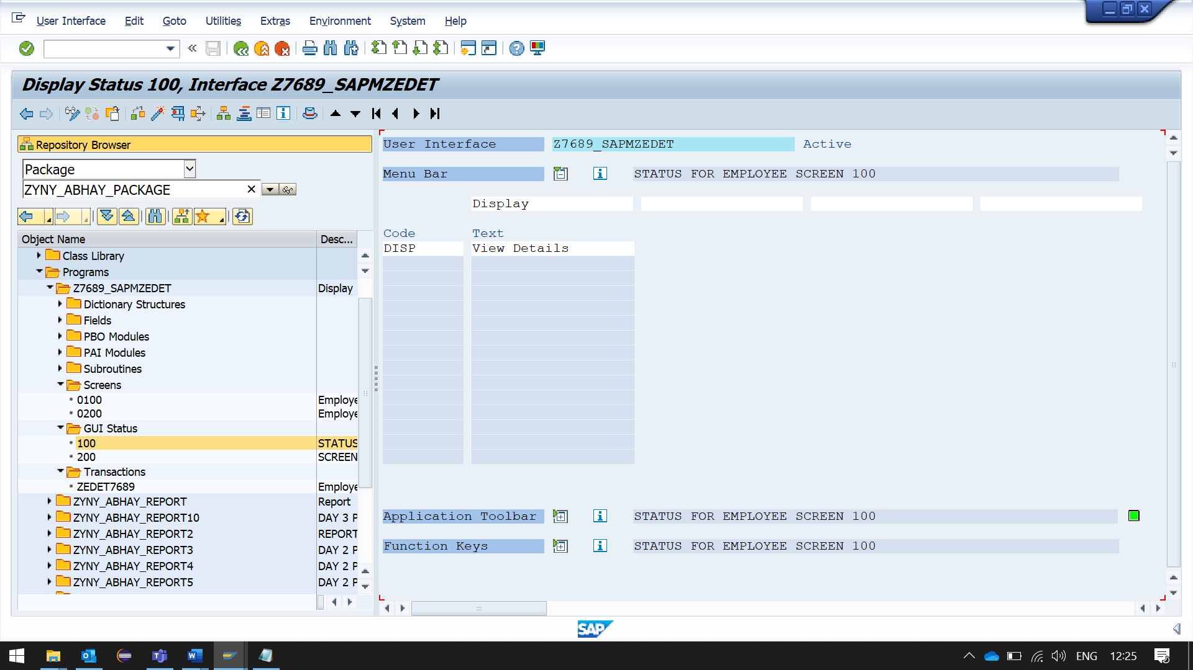

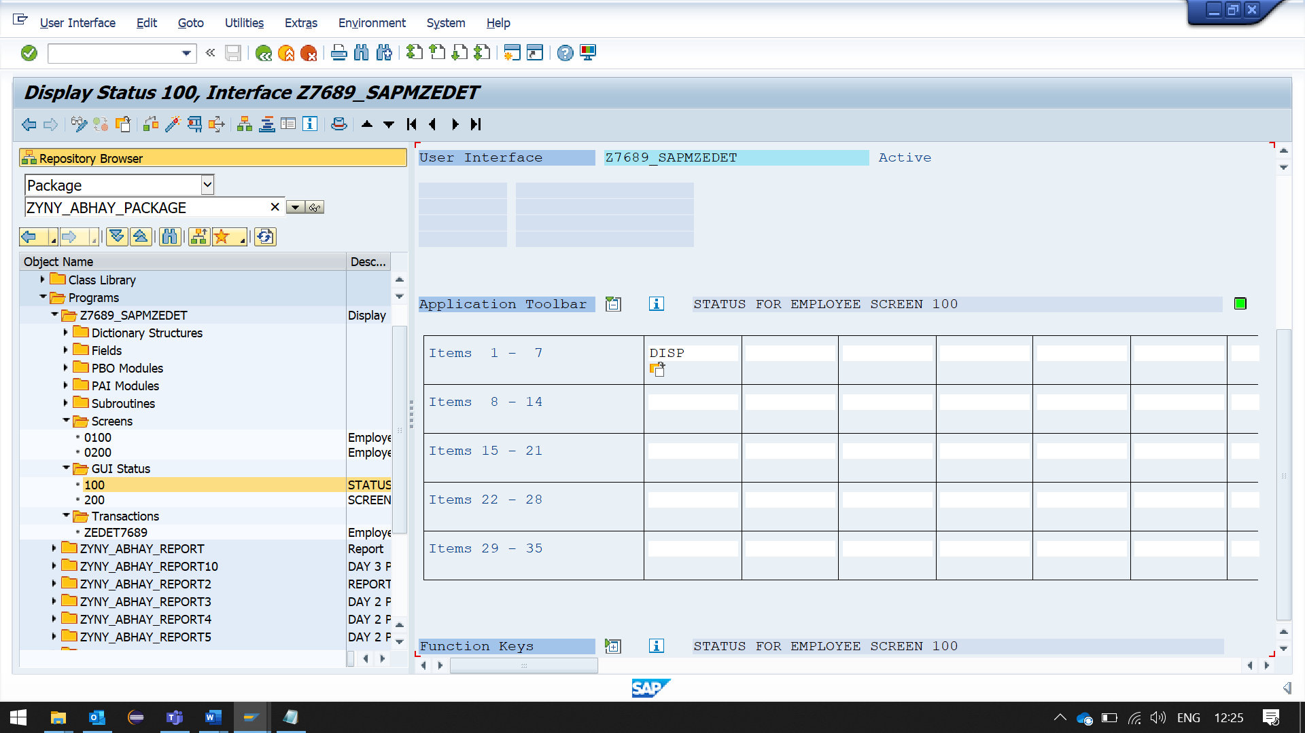

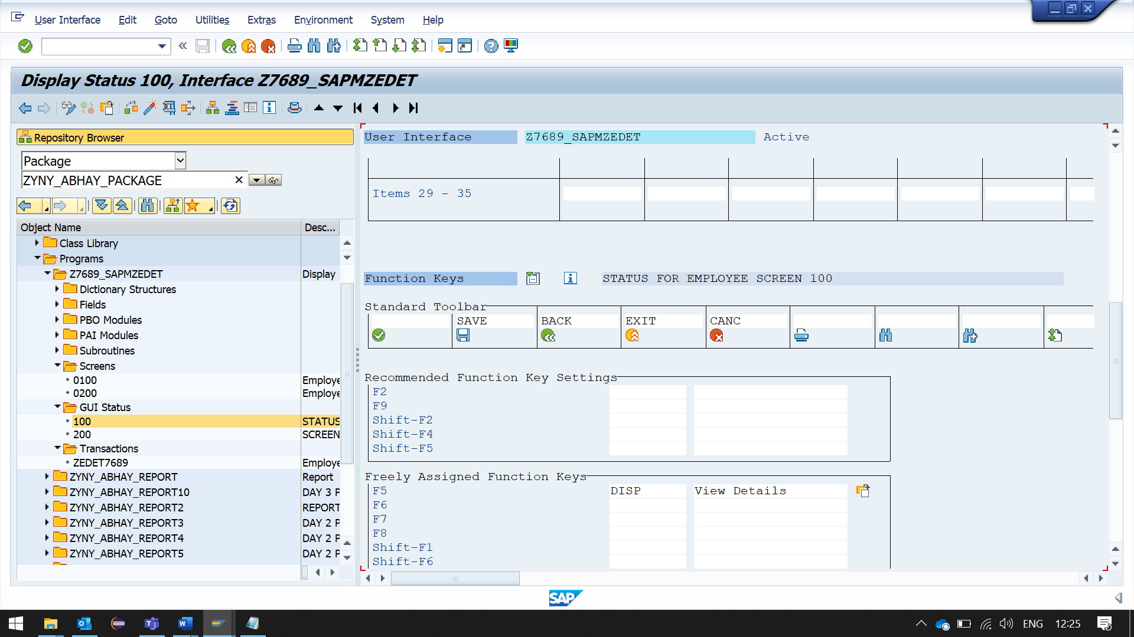

**Generate Screens using Screen Painter (Screen 0200)**

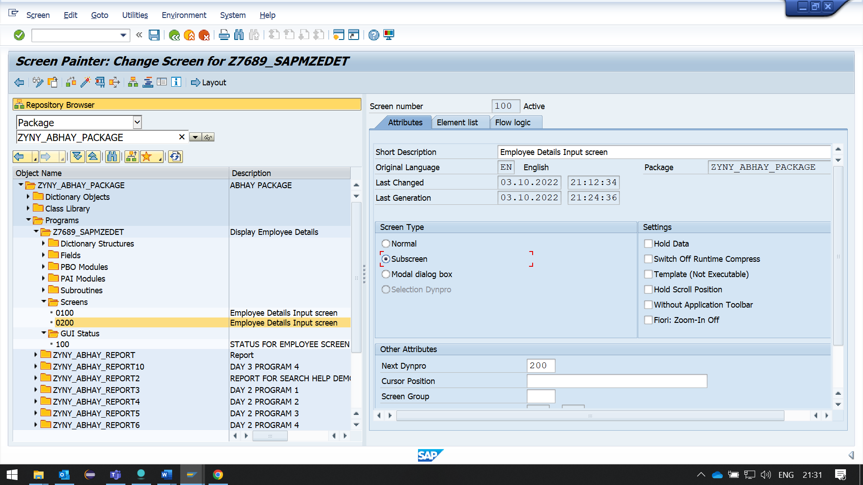

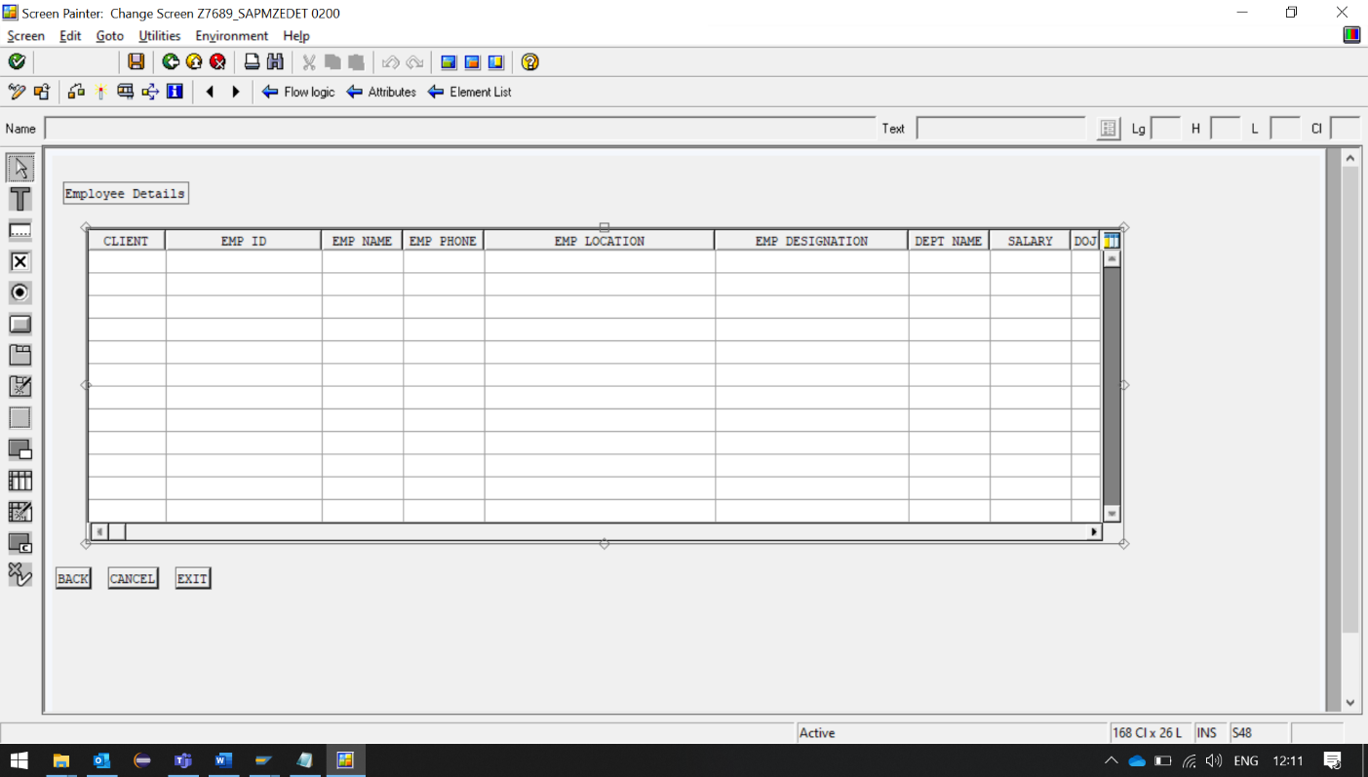

**Building the Flow Logic (Screen 0200)**

**Process After Input (PAI) module (Screen 0200)-**

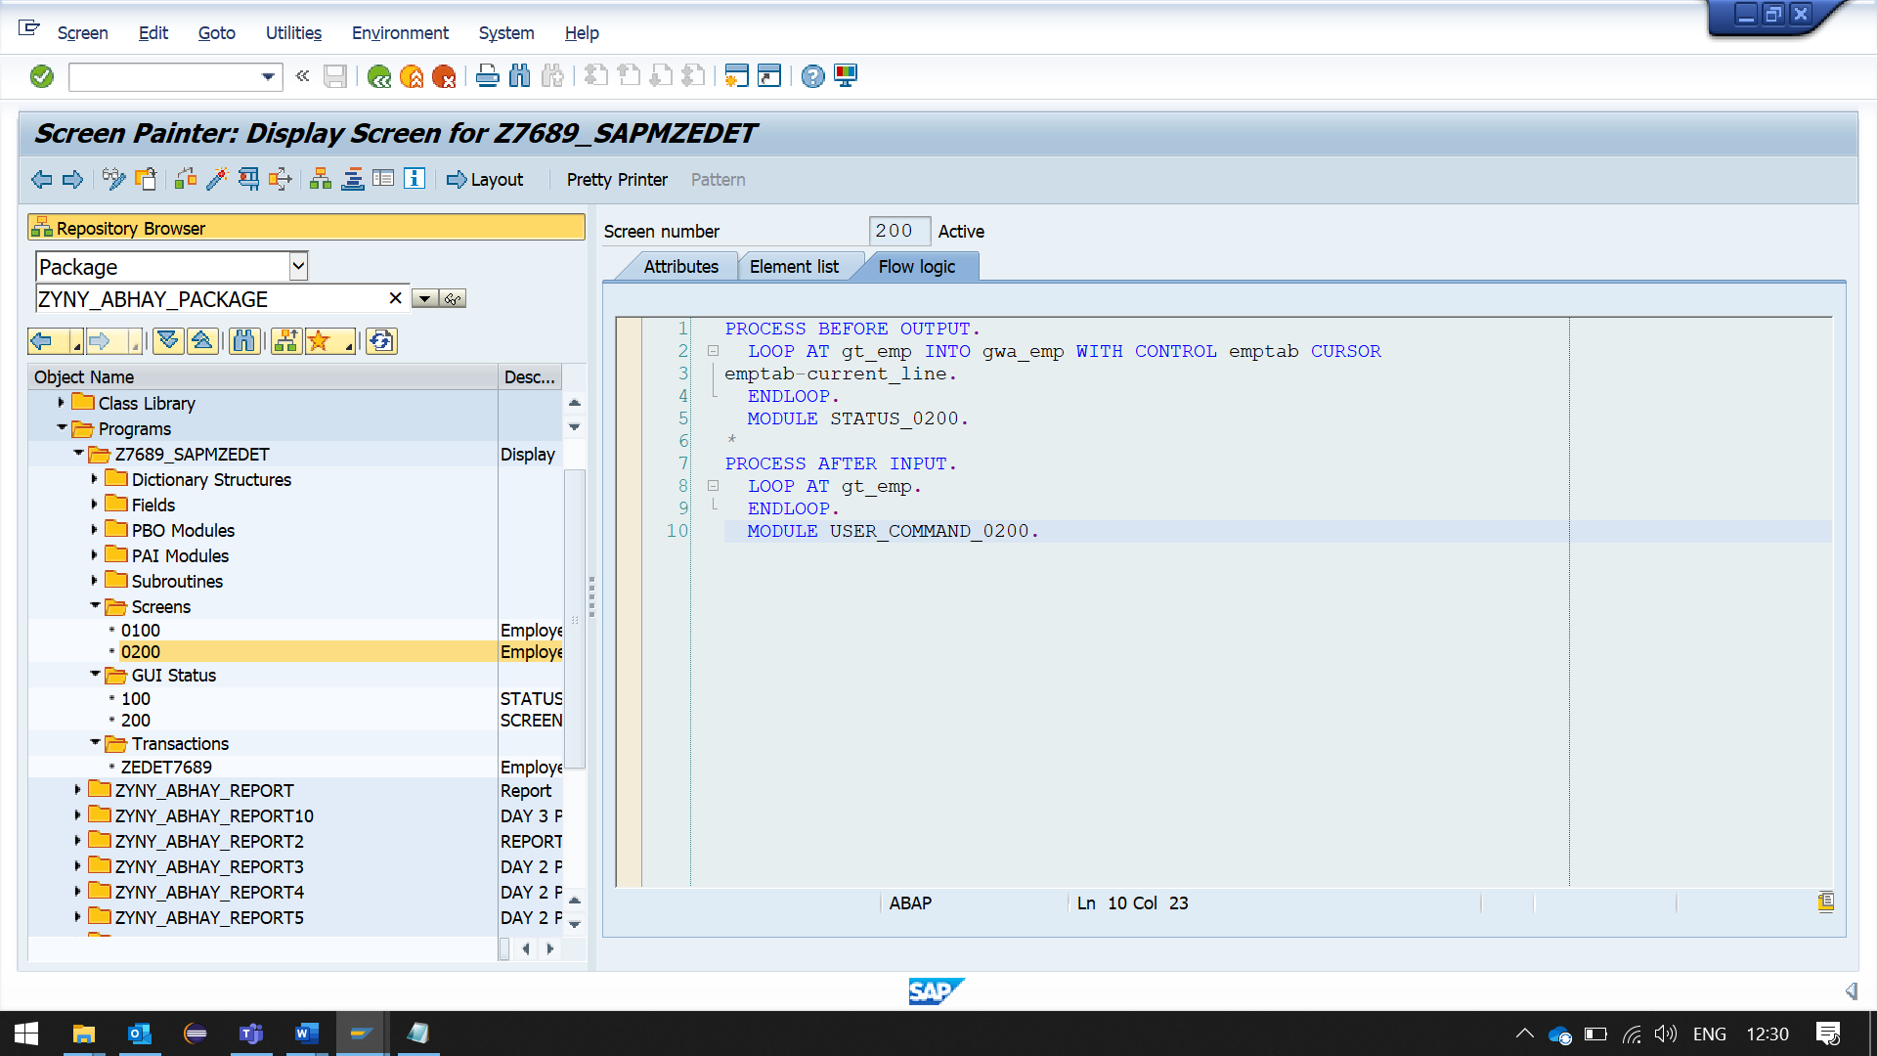

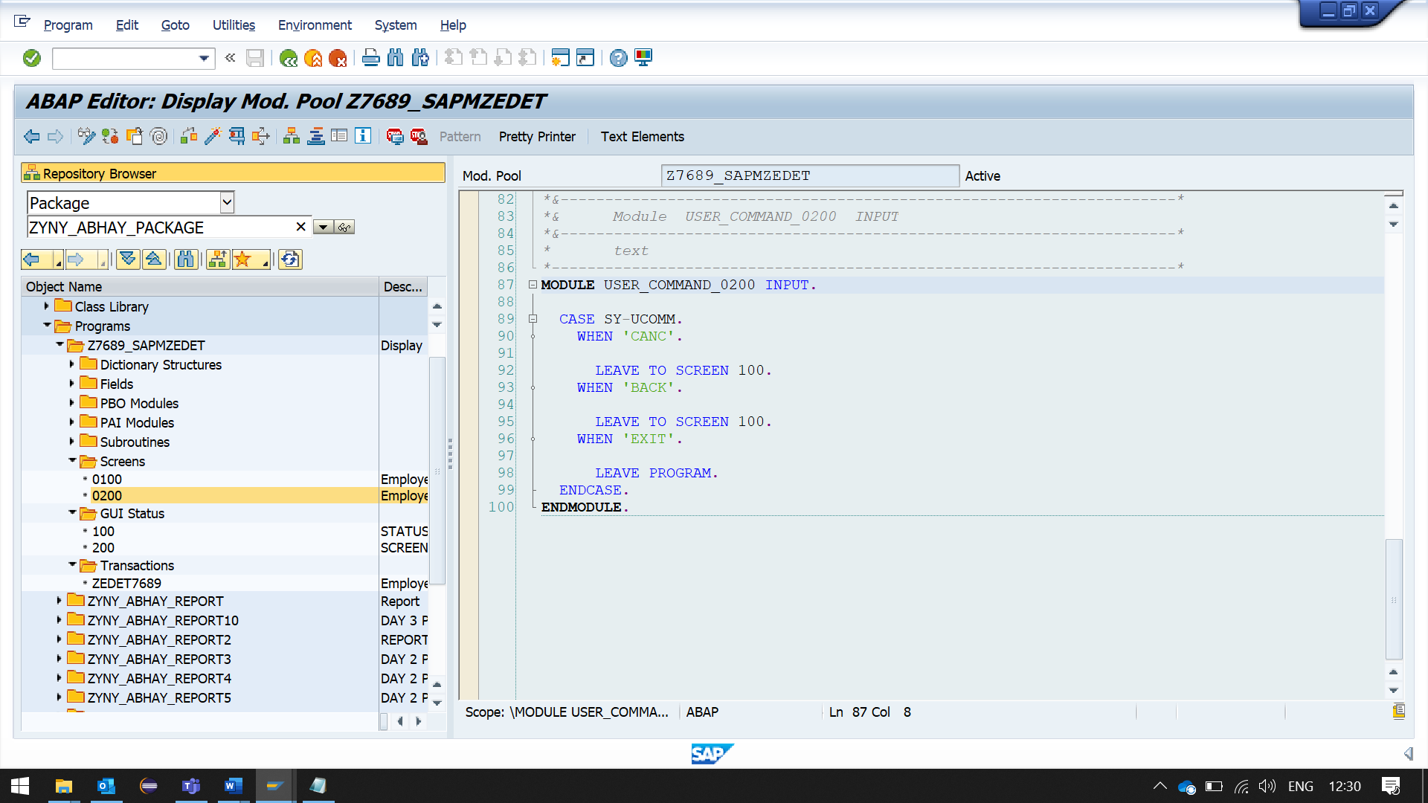

**Process Before Output (PBO) module (Screen 0200)-**

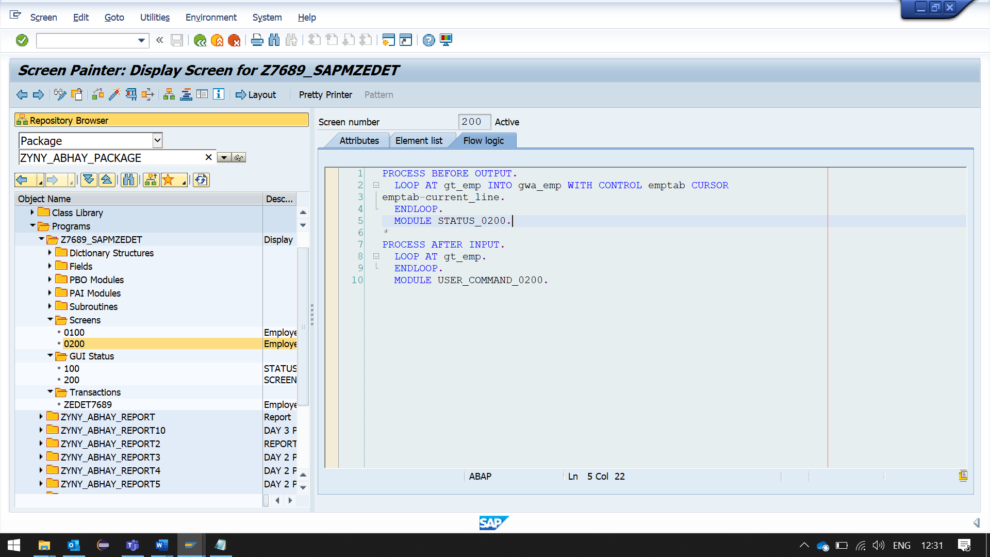

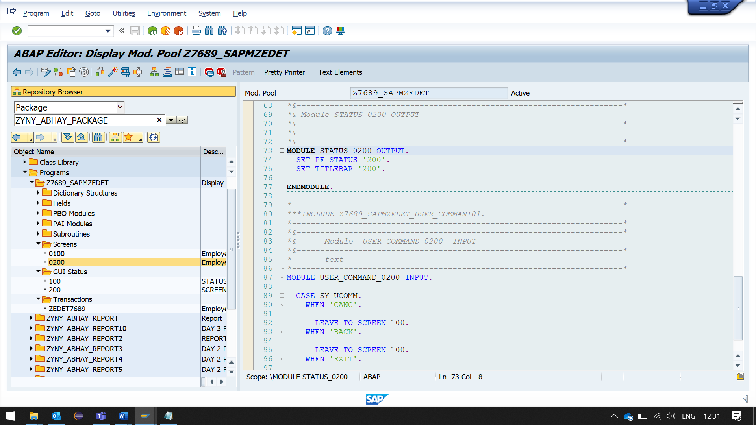

**Creating a GUI Status for the screen 200**

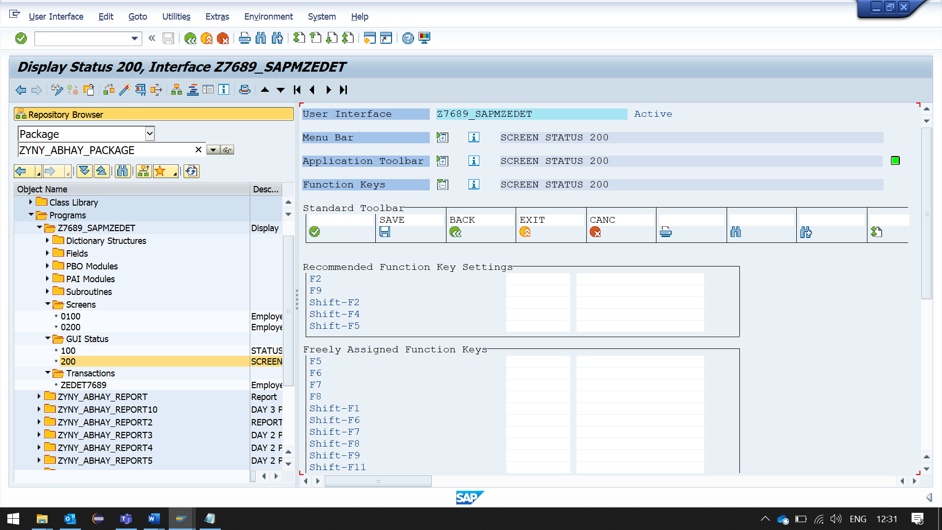

**Creating a Transaction code and attaching the module pool program to the Transaction**

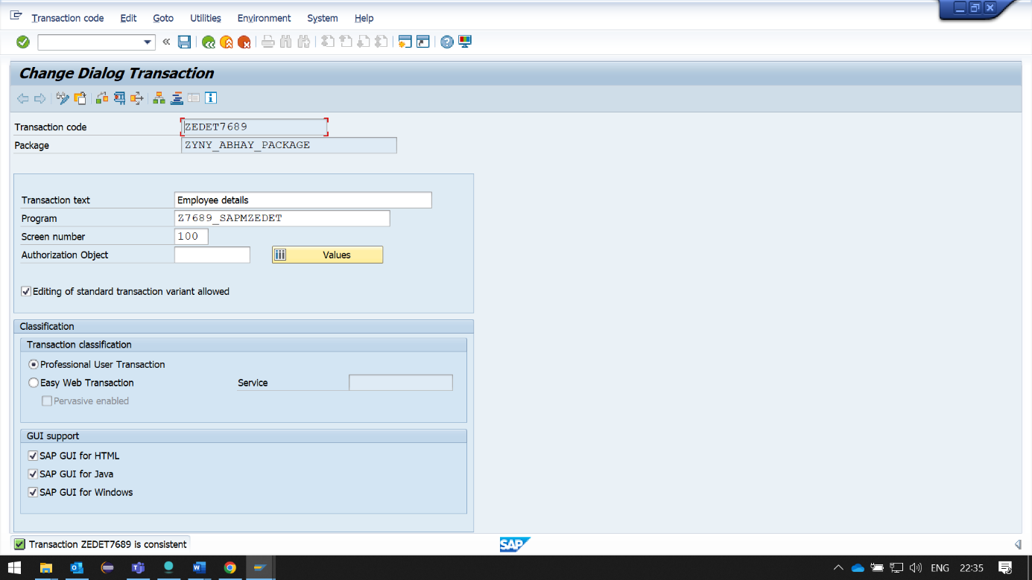

**PROGRAM -**

*\*&---------------------------------------------------------------------\**  
*\*& Module Pool      Z7689_SAPMZEDET*  
*\*&---------------------------------------------------------------------\**  
*\*&*  
*\*&---------------------------------------------------------------------\**  
PROGRAM Z7689_SAPMZEDET.  
  
TABLES: ZEMP7689.  
  
CONTROLS emptab TYPE TABLEVIEW USING SCREEN '0200'.  
  
DATA: gt_emp TYPE STANDARD TABLE OF ZEMP7689.  
DATA: gwa_emp TYPE ZEMP7689.  
  
*\*&---------------------------------------------------------------------\**  
*\*&      Module  USER_COMMAND_0100  INPUT*  
*\*&---------------------------------------------------------------------\**  
*\*       text*  
*\*----------------------------------------------------------------------\**  
MODULE USER_COMMAND_0100 INPUT.  
  CASE SY-UCOMM.  
    WHEN 'DISP'.  
      REFRESH GT_EMP.  
      perform read_data.  
      Call screen 200.  
  
    WHEN 'CANC'.  
  
      SET SCREEN 0. LEAVE SCREEN.  
    WHEN 'BACK'.  
  
      SET SCREEN 0. LEAVE SCREEN.  
    WHEN 'EXIT'.  
  
      LEAVE PROGRAM.  
  ENDCASE.  
ENDMODULE.  
*\*&---------------------------------------------------------------------\**  
*\*& Form READ_DATA*  
*\*&---------------------------------------------------------------------\**  
*\*& text*  
*\*&---------------------------------------------------------------------\**  
*\*& -->  p1        text*  
*\*& <--  p2        text*  
*\*&---------------------------------------------------------------------\**  
FORM READ_DATA .  
  SELECT SINGLE * FROM ZEMP7689  
    INTO CORRESPONDING FIELDS OF gwa_emp  
    WHERE EMP_id EQ GWA_EMP-EMP_ID.  
    WRITE : GWA_EMP-EMP_NAME.  
  IF sy-subrc EQ 0.  
    APPEND gwa_emp TO gt_emp.  
  ENDIF.  
ENDFORM.  
*\*&---------------------------------------------------------------------\**  
*\*& Module STATUS_0100 OUTPUT*  
*\*&---------------------------------------------------------------------\**  
*\*&*  
*\*&---------------------------------------------------------------------\**  
MODULE STATUS_0100 OUTPUT.  
  SET PF-STATUS '100'.  
  SET TITLEBAR '100'.  
ENDMODULE.  
  
*\*----------------------------------------------------------------------\**  
*\*\*\*INCLUDE Z7689_SAPMZEDET_STATUS_0200O01.*  
*\*----------------------------------------------------------------------\**  
*\*&---------------------------------------------------------------------\**  
*\*& Module STATUS_0200 OUTPUT*  
*\*&---------------------------------------------------------------------\**  
*\*&*  
*\*&---------------------------------------------------------------------\**  
MODULE STATUS_0200 OUTPUT.  
  SET PF-STATUS '200'.  
  SET TITLEBAR '200'.  
  
ENDMODULE.  
  
*\*----------------------------------------------------------------------\**  
*\*\*\*INCLUDE Z7689_SAPMZEDET_USER_COMMANI01.*  
*\*----------------------------------------------------------------------\**  
*\*&---------------------------------------------------------------------\**  
*\*&      Module  USER_COMMAND_0200  INPUT*  
*\*&---------------------------------------------------------------------\**  
*\*       text*  
*\*----------------------------------------------------------------------\**  
MODULE USER_COMMAND_0200 INPUT.  
  
  CASE SY-UCOMM.  
    WHEN 'CANC'.  
  
      LEAVE TO SCREEN 100.  
    WHEN 'BACK'.  
  
      LEAVE TO SCREEN 100.  
    WHEN 'EXIT'.  
  
      LEAVE PROGRAM.  
  ENDCASE.  
ENDMODULE.

**OUTPUT**

**T CODE - ZEDET7689**



